Task: Data Analysis

**1A. In what city Fond Rouge loses the highest % revenue due to returns?**(Where the ratio refund:revenue is the highest?)

Lyon and Toulouse

**1B. Paste a screenshot of your Stacked Bar chart of Revenue & Refund per US city.**

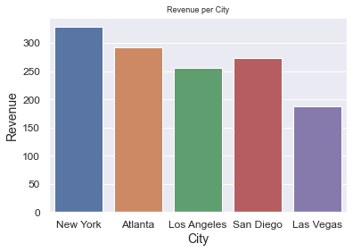

**2A. What is the % NEG Class-ifiers in the US?**  
((Number of all sales with Sentiment Class=NEG in the US) / (Number of all sales in the US) * 100)

10.46%

**2B. Paste a screenshot of your Donut chart of Sentiment Class in the US**

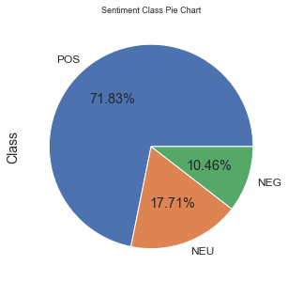

**3A. What is the % NEG Class-ifiers, Globally?**  
((Number of all sales with Sentiment Class=NEG) / (Number of all sales) * 100)

10.45%

**3B. Paste a screenshot of your Donut chart of Sentiment Class, Globally.**

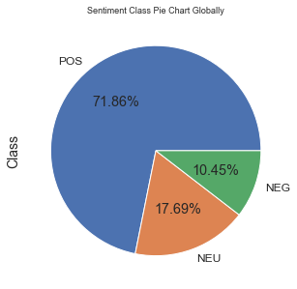

**4A. List the locations where counterfeiting may be happening?**(Hint: look for cities where the returns are lower than 20%, but the Sentiment is low (under 65))

'Brussels', 'Prague', 'Tallinn', 'Dublin', 'Madrid', 'Paris', 'Lyon', 'Toulouse', 'Rome', 'Amsterdam', 'Rotterdam', 'Vienna', 'Warsaw', 'Lisbon', 'London', 'New York', 'Atlanta', 'Los Angeles',

'San Diego', 'Copenhagen', 'Bucharest', 'Stockholm', 'Liverpool', 'Sofia', 'Helsinki', 'Las Vegas', 'Zürich',

'Genève', 'Berlin'

**4B. Paste a screenshot of your Column & Line chart of Refund/Revenue & Avg Sentiment per US city.**

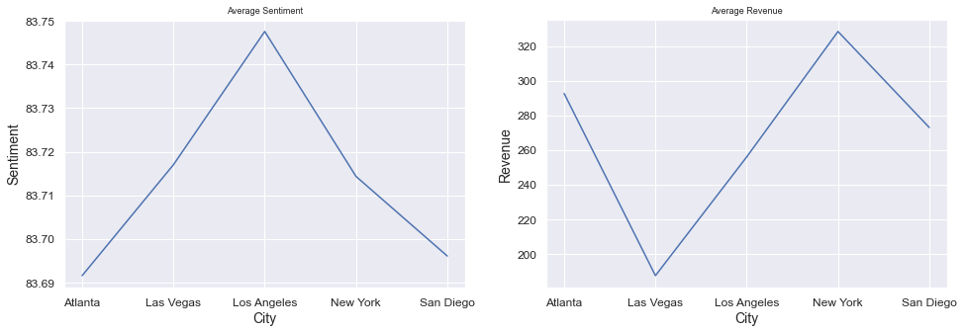

**5. Does Fond Rouge have a problem in all of its American locations? How can you tell?**

Only San Diego, low sentiment and drop revenue

**6. Is counterfeit the only problem that’s observable in Fond Rouge’s data for its US operation? Why?**

Hard to tell as need more relevant data on this.

**7. Paste a screenshot of your GeoMap (Bubble Layer) of Location, Avg Sentiment, Revenue.**

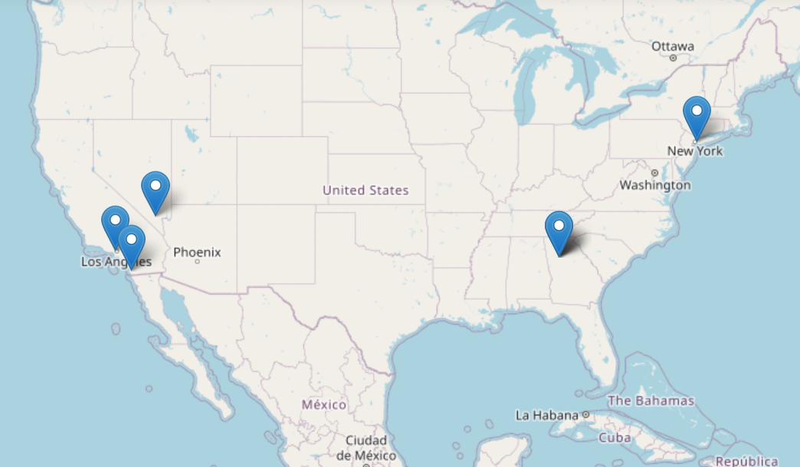

**8. Paste the login url for your SAP Analytics Cloud tenant.**(If you are logged in SAC – just copy & paste your browser url, no matter where in SAC you currently are)